International Cybersecurity and Digital Forensics Academy (ICDFA)
CIP-B103: Network Forensics Fundamentals
LAB 3: SYN Flood Attack Investigation Using tshark
Three-Week Delivery Block 1/3 | 18-19 July 2026
Prepared by: Aminu Idris, AMCPN | Founder, ICDFA
Important Pre-Lab Instruction
Read the matching lecture slide deck before executing the practical. Work only inside the ICDFA-approved lab or your own isolated virtual environment. Record every command, observation and screenshot as contemporaneous evidence.
Course Code | CIP-B103
Course Title | Network Forensics Fundamentals
Student Name | Fuseini Imoru Kantuogaa
Instructor’s Name | Dr. Sarah James
Lab Number | Lab 3
Lab Title | SYN Flood Attack Investigation Using tshark
Delivery Block | 1/3 of 3
Scheduled Dates | 18-19 July 2026
Estimated Duration | 3-4 hours practical work plus report writing
Mode | Individual practical lab in an authorized virtual environment
Required Evidence | mySYNFloodCapture.pcap or a bounded loopback capture generated in the lab

1. Source Materials and Slide Alignment
- HTTP, tshark and SYN Flood: TCP three-way handshake, half-open connections, SYN flood concept, Scapy packet generation and tshark capture.
- The uploaded slide uses Apache on port 80, loopback capture and a four-packet controlled simulation.
- The assignment requires two authorized VMs or an equivalent isolated environment and evidence that distinguishes attack-like SYN activity from a normal handshake.
Reading Requirement Before Lab Execution
The lab deliberately follows the sequence, terminology and core exercises presented in the uploaded CIP-B103 slides. Commands have been corrected where needed for Linux syntax and forensic repeatability.

2. Lab Scenario
An Apache service experienced repeated TCP SYN packets that were not followed by the final ACK of the three-way handshake. You will preserve the packet capture, establish a normal-traffic baseline, identify suspicious SYN patterns, calculate indicators, and conduct a strictly bounded loopback simulation to validate your interpretation.

3. Learning Outcomes
- Differentiate a complete TCP handshake from an incomplete or half-open attempt.
- Use tshark display filters and field extraction to identify SYN, SYN-ACK, ACK and reset packets.
- Calculate SYN counts, unique source ports, response behaviour and incomplete-handshake indicators.
- Create a four-packet loopback-only simulation with Scapy in an authorized environment.
- Develop a defensible timeline and incident finding from PCAP evidence.
- Recommend controls for detecting and mitigating SYN flood activity.

4. Legal, Ethical and Safety Rules
- Use only systems, packet captures and networks for which you have explicit authorization.
- Keep the lab isolated from production, campus, office and public networks. Use NAT or host-only virtual networking as instructed.
- Do not collect, disclose or reuse real credentials, personal messages or confidential traffic.
- Preserve original capture files. Perform analysis on verified working copies and record SHA-256 hashes.
- Stop any traffic-generation or interception process immediately after the required evidence is captured.
- Restore firewall, ARP, forwarding and network settings before closing the lab.
- The simulation is limited to four SYN packets against 127.0.0.1 or an instructor-assigned private lab IP. Do not increase packet count, automate continuous sending, spoof third-party addresses or target public systems.

5. Required Tools and Environment
Item | Recommended Tool | Purpose
Operating system | Kali Linux VM | Run tshark, Apache and Scapy.
Target service | Local Apache on 127.0.0.1:80 | Safe target for bounded simulation.
Capture tool | tshark/Wireshark | Capture and analyze TCP flags.
Packet library | python3-scapy | Generate a small number of SYN packets.
Evidence | Provided PCAP or student capture | Forensic analysis source.
Optional second VM | Authorized host-only target | Demonstrate network capture without touching external networks.

6. Lab Folder Structure and Evidence Preparation
mkdir -p ~/CIP-B103-Lab3/{evidence,working,exported,reports,screenshots,scripts}
cd ~/CIP-B103-Lab3
pwd
find . -maxdepth 1 -type d -print
Create the folder structure before downloading or generating evidence. Store original captures under evidence and analysis copies under working.
sudo apt update
sudo apt install -y apache2 tshark wireshark python3-scapy
sudo systemctl enable --now apache2
# Optional supplied capture
wget -O evidence/mySYNFloodCapture.pcap \
'https://raw.githubusercontent.com/frankwxu/digital-forensics-lab/main/Illegal_Possession_Images/lab_files/SYN_Flood/mySYNFloodCapture.pcap'
sha256sum evidence/mySYNFloodCapture.pcap | tee reports/syn_capture_sha256.txt
Screenshot required: The Apache service state, evidence file details and SHA-256 hash.
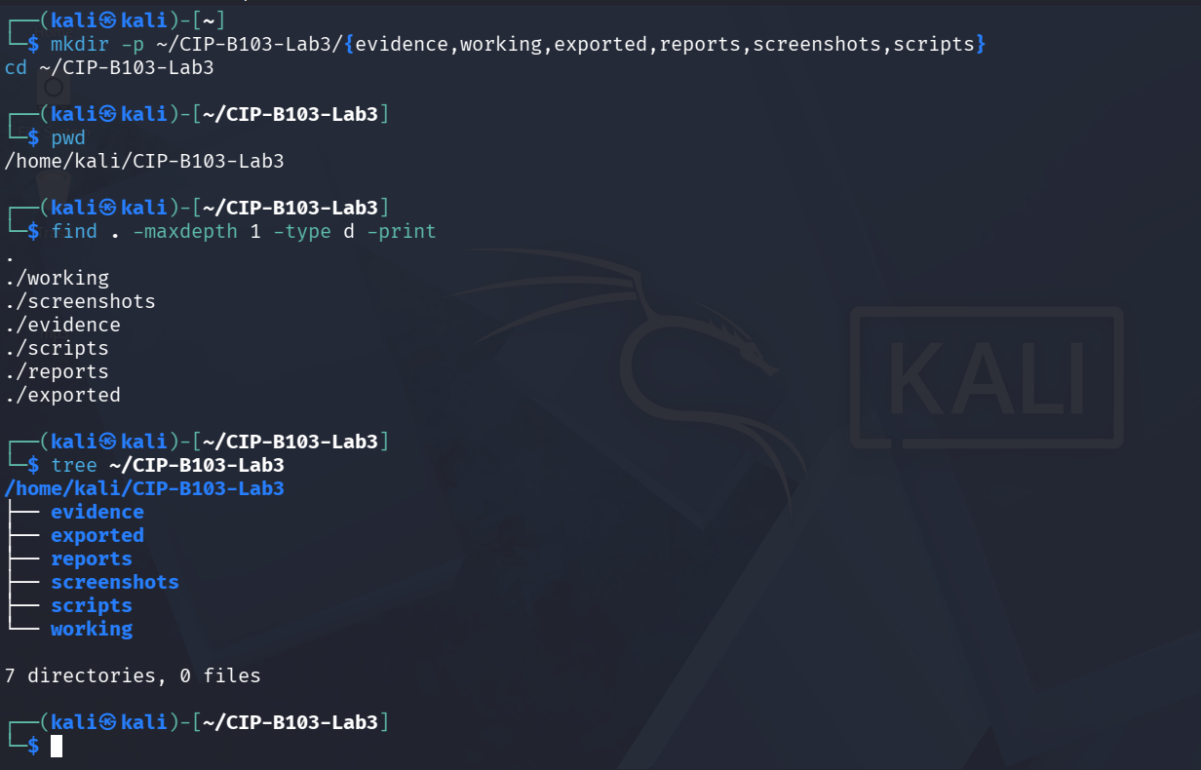
Screenshot 1: Evidence folder structure created (mkdir, cd, pwd, find, tree).
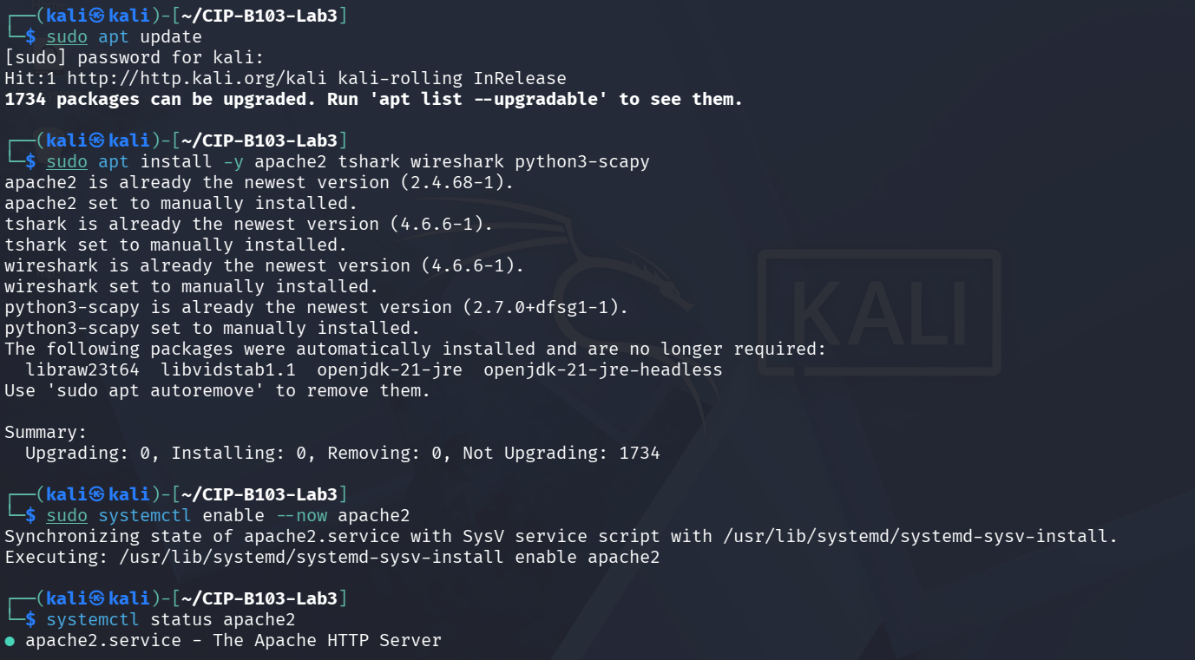
Screenshot 2: Package updates, tool installation, and apache2 enabled.
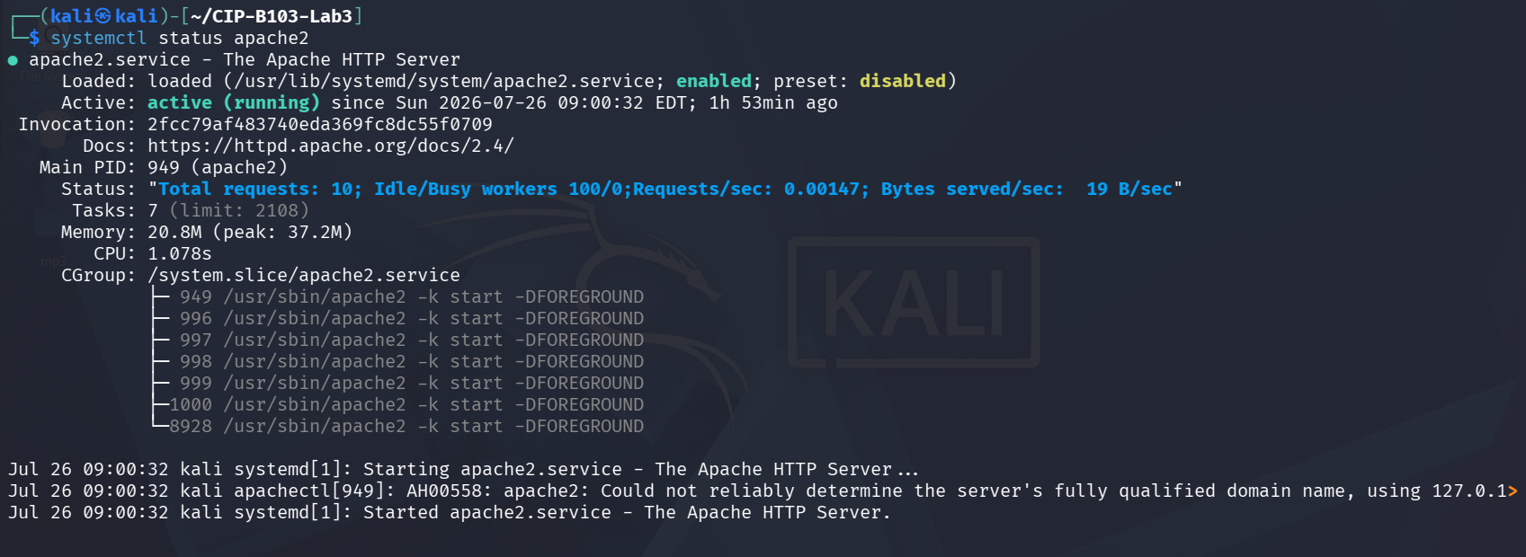
Screenshot 3: systemctl status confirming Apache2 active and listening.
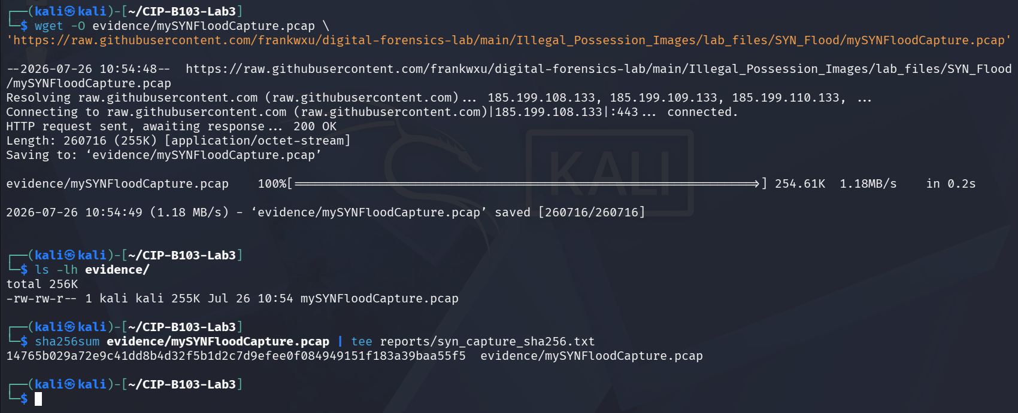
Screenshot 4: mySYNFloodCapture.pcap downloaded, listed, and SHA-256 hashed.

7. Mini Evidence and Chain-of-Custody Worksheet
Field | Student Entry
Case/lab identifier | CIP-B103-Lab3-YourFullName
Trainee name | [Insert trainee full name — not shown in the supplied screenshots; terminal user is ‘kali’]
Date and time started | 26 July 2026, approx. 08:55–09:00 local (Kali VM) — inferred from the Apache2 service start time (09:00:32 EDT) shown in systemctl status
Evidence file name(s) | mySYNFloodCapture.pcap; normal_http.pcapng; bounded_syn_activity.pcapng (working copy: bounded_syn_activity_working.pcapng)
Source or generation method | mySYNFloodCapture.pcap downloaded via wget from the course GitHub repository (supplied reference evidence); normal_http.pcapng and bounded_syn_activity.pcapng captured locally with tshark on loopback (lo, tcp port 80) while Apache2 served requests and a 4-packet Scapy SYN probe (scripts/syn_probe_lab.py) ran
Original SHA-256 | mySYNFloodCapture.pcap: 14765b029a72e9c41dd8b4d32f5b1d2c7d9efeedf084949151f183a39baa55f5 — bounded_syn_activity.pcapng: 695f2e51f86fc56e493e09caef1badfc189f42a609204fb38dea63bb1f1ae944
Working-copy SHA-256 | bounded_syn_activity_working.pcapng: 695f2e51f86fc56e493e09caef1badfc189f42a609204fb38dea63bb1f1ae944 — identical to original
Analysis workstation/VM | Kali Linux (user: kali), CIP-B103-Lab3 working directory
Notes on any changes | None. cp --preserve=timestamps used for the bounded-activity working copy; SHA-256 matched exactly. normal_http.pcapng was captured directly to evidence/ as root then chown'd to kali:kali (ownership only, no content change).

8. Part A - Establish a Normal Handshake Baseline
sudo tshark -i lo -f 'tcp port 80' -a duration:15 -w evidence/normal_http.pcapng &
sleep 2
curl --no-keepalive http://127.0.0.1/ >/dev/null
wait
tshark -r evidence/normal_http.pcapng -Y 'tcp.flags.syn==1 || tcp.flags.fin==1' -T fields \
-e frame.number -e frame.time -e ip.src -e tcp.srcport -e ip.dst -e tcp.dstport -e tcp.flags \
| tee reports/normal_handshake_flags.tsv
Document the expected SYN, SYN-ACK and ACK sequence before examining suspicious traffic.
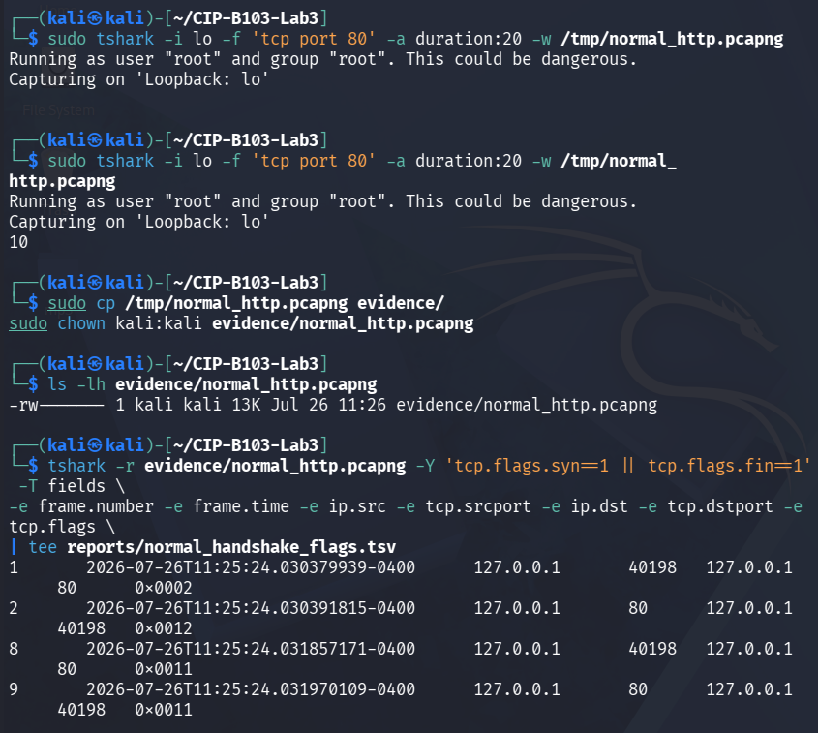
Screenshot 5: Baseline tshark capture on loopback, copied/chowned, and SYN/FIN flag extraction.
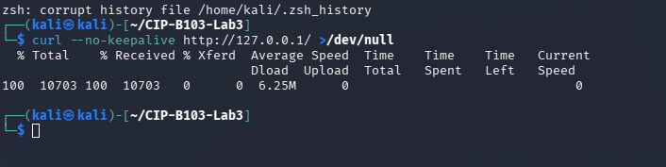
Screenshot 6: curl request to the local Apache service generating the normal HTTP session.

9. Part B - Conduct the Bounded Loopback Simulation
Create the following script exactly. It sends four SYN packets to the local Apache service and then exits. It does not run continuously and does not target another organization.
cat > scripts/syn_probe_lab.py <<'PYLAB'
from scapy.all import IP, TCP, RandShort, send
TARGET = '127.0.0.1'
PORT = 80
COUNT = 4
packets = [IP(dst=TARGET)/TCP(sport=RandShort(), dport=PORT, flags='S') for _ in range(COUNT)]
send(packets, verbose=False)
print(f'Sent {COUNT} authorized training SYN packets to {TARGET}:{PORT}')
PYLAB
# Terminal 1
sudo tshark -i lo -f 'tcp port 80' -c 20 -w evidence/bounded_syn_activity.pcapng
# Terminal 2, while capture is running
sudo python3 scripts/syn_probe_lab.py
Stop Condition
If the capture reaches 20 packets it stops automatically. Otherwise stop with Ctrl+C immediately after the four SYN packets and associated responses are captured.
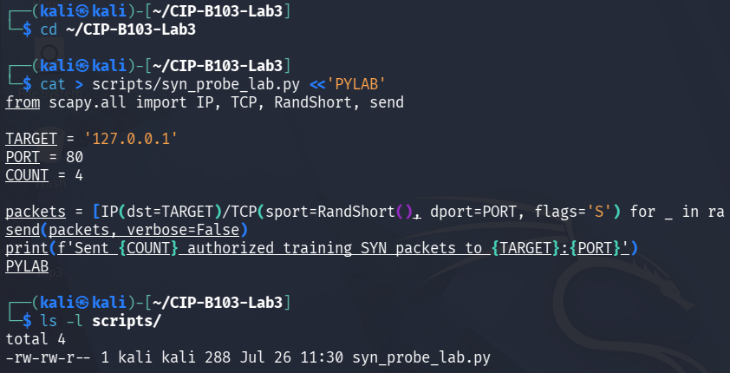
Screenshot 7: Bounded 4-packet Scapy SYN probe script created and listed.
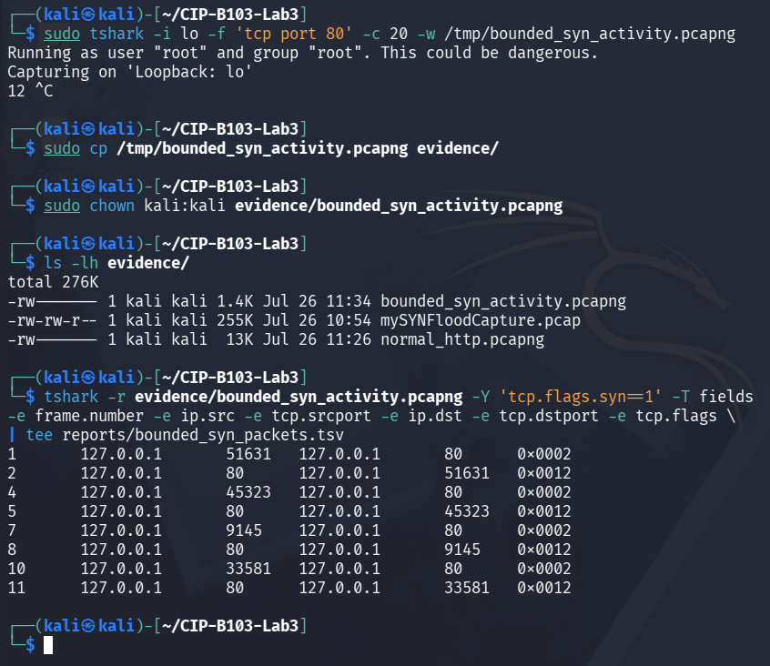
Screenshot 8: Bounded loopback capture started, copied/chowned, and SYN packet list extracted.
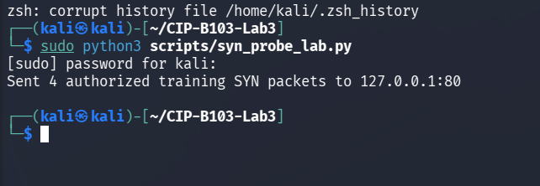
Screenshot 9: syn_probe_lab.py executed, sending 4 authorized training SYN packets.
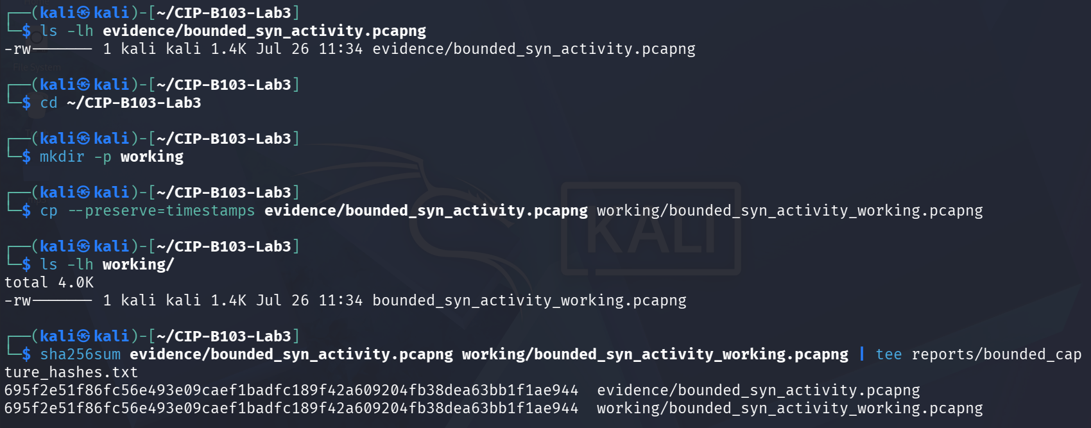
Screenshot 10: Working copy created and SHA-256 hashes of evidence and working captures matched.

10. Part C - Identify SYN Indicators with tshark
PCAP=working/bounded_syn_activity_working.pcapng
cp --preserve=timestamps evidence/bounded_syn_activity.pcapng "$PCAP"
sha256sum evidence/bounded_syn_activity.pcapng "$PCAP" | tee reports/bounded_capture_hashes.txt
# Initial SYNs only
tshark -r "$PCAP" -Y 'tcp.flags.syn==1 && tcp.flags.ack==0' -T fields \
-e frame.number -e frame.time_epoch -e ip.src -e tcp.srcport -e ip.dst -e tcp.dstport -e tcp.seq \
| tee reports/initial_syns.tsv
# SYN-ACK responses
tshark -r "$PCAP" -Y 'tcp.flags.syn==1 && tcp.flags.ack==1' -T fields \
-e frame.number -e frame.time_epoch -e ip.src -e tcp.srcport -e ip.dst -e tcp.dstport -e tcp.ack \
| tee reports/syn_ack_responses.tsv
# Resets and final ACK candidates
tshark -r "$PCAP" -Y 'tcp.flags.reset==1 || (tcp.flags.ack==1 && tcp.len==0)' -T fields \
-e frame.number -e frame.time_epoch -e ip.src -e tcp.srcport -e ip.dst -e tcp.dstport -e tcp.flags \
| tee reports/ack_reset_candidates.tsv
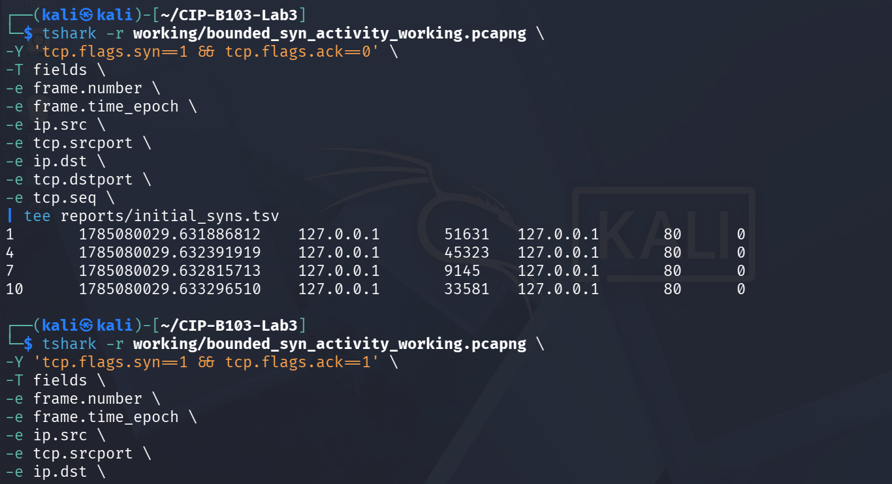
Screenshot 11: Initial SYN extraction and start of SYN-ACK response extraction.
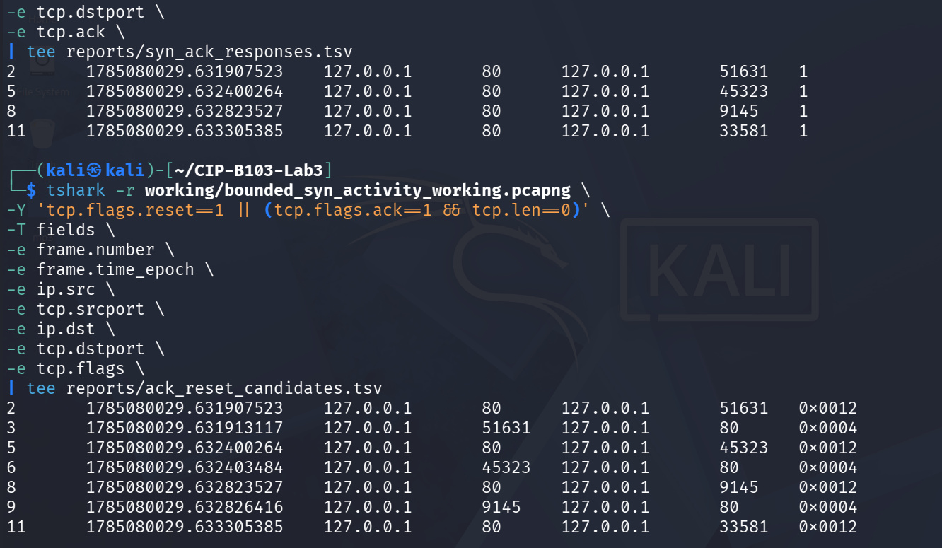
Screenshot 12: SYN-ACK responses and RST/final-ACK candidate extraction results.

11. Part D - Quantify and Correlate the Activity
# Counts by source and destination
tshark -r "$PCAP" -Y 'tcp.flags.syn==1 && tcp.flags.ack==0' -T fields \
-e ip.src -e ip.dst -e tcp.dstport | sort | uniq -c | sort -nr \
| tee reports/syn_counts_by_pair.txt
# Unique client source ports
tshark -r "$PCAP" -Y 'tcp.flags.syn==1 && tcp.flags.ack==0' -T fields -e tcp.srcport \
| sort -n | uniq | tee reports/unique_syn_source_ports.txt
# Expert information and TCP analysis flags
tshark -r "$PCAP" -q -z expert | tee reports/expert_info.txt
tshark -r "$PCAP" -Y 'tcp.analysis.retransmission || tcp.analysis.lost_segment || tcp.analysis.duplicate_ack' \
-T fields -e frame.number -e frame.time -e _ws.col.Info | tee reports/tcp_analysis_events.tsv
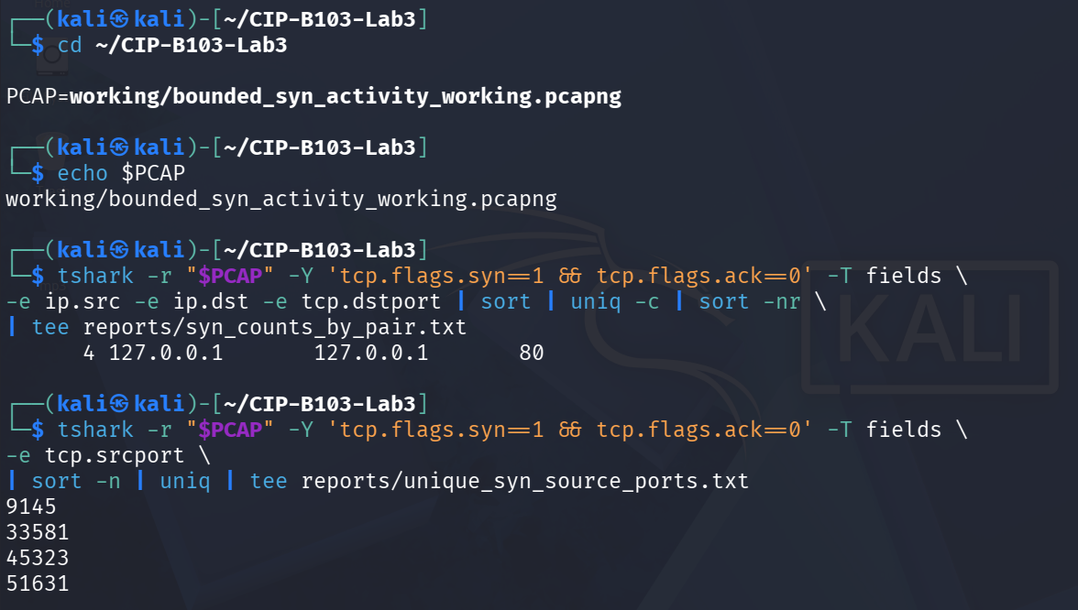
Screenshot 13: SYN counts by source/destination pair and unique source ports.
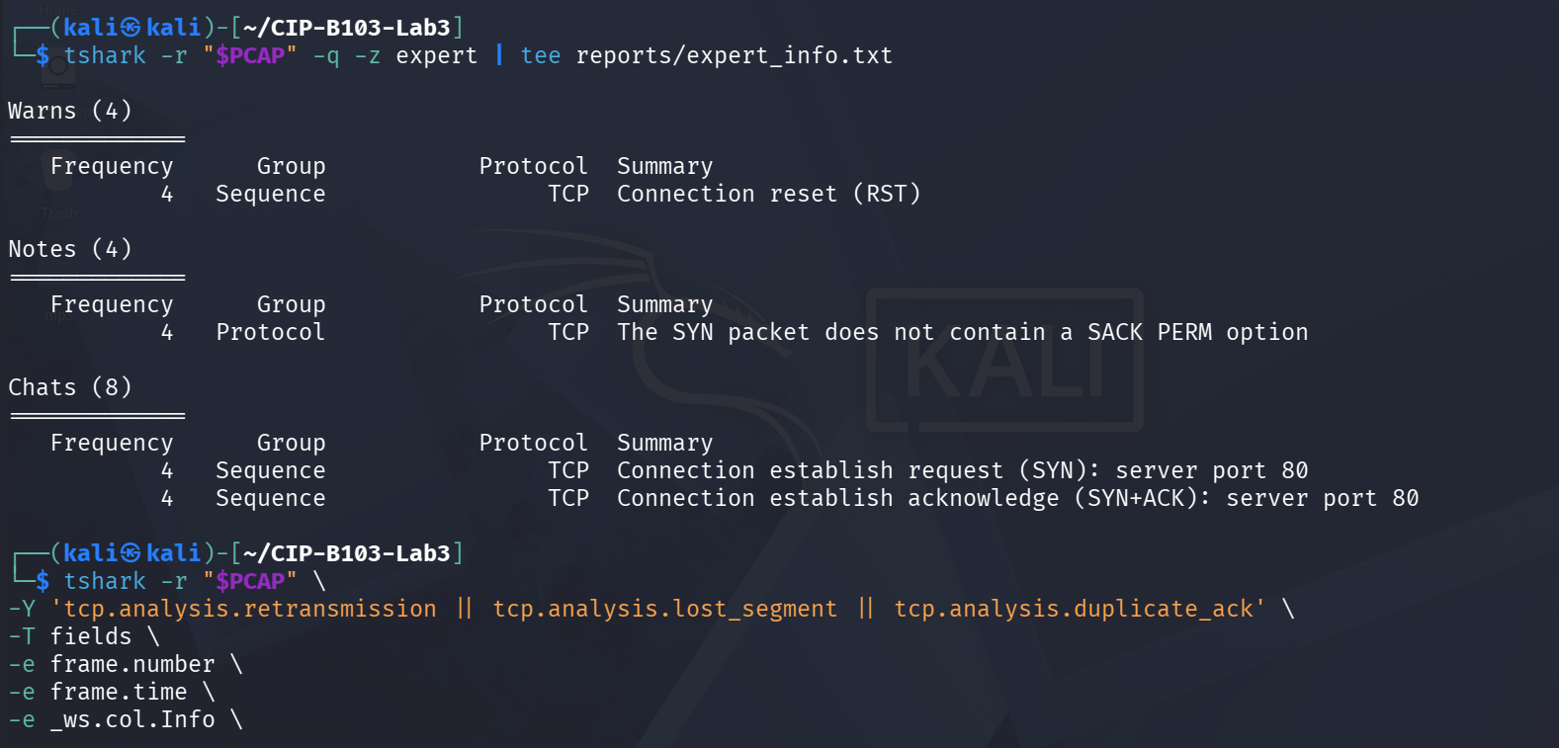
Screenshot 14: Expert information summary and TCP analysis events query.

12. Part E - Compare Normal and Suspicious Sessions
Indicator | Normal HTTP Session | Bounded SYN Activity | Forensic Meaning
Initial SYN count | 1 (frame 1, source port 40198) | 4 (frames 1, 4, 7, 10; ports 9145, 33581, 45323, 51631) | A single handshake attempt vs. four near-simultaneous SYNs from distinct ephemeral ports — the signature of scripted packet generation rather than normal browsing.
SYN-ACK count | 1 (frame 2) | 4 (frames 2, 5, 8, 11) — the server answered every SYN | Apache/the kernel responded 1:1 in both cases; SYN-ACK volume alone does not distinguish attack from bounded test — completion behaviour does.
Completed handshakes | 1 of 1 (confirmed by the successful HTTP GET/response in the curl output) | 0 of 4 — each SYN-ACK was answered with an immediate client-side RST (frames 3, 6, 9 and the equivalent for stream 4) instead of a final ACK | Zero completed handshakes despite four SYN-ACKs is the core half-open indicator associated with SYN flood behaviour.
Unique client source ports | 1 (40198) | 4 (9145, 33581, 45323, 51631) | Multiple distinct ephemeral source ports appearing within milliseconds indicates scripted packet generation, not a single browser session.
HTTP request present? | Yes — GET / returned 10,703 bytes to curl | No — no application-layer traffic; only SYN/SYN-ACK/RST at the TCP layer | Absence of any application-layer exchange confirms the bounded activity never reached a usable connection.
RST packets | 0 | 4 (one per stream, immediately following each SYN-ACK) | Client-generated RSTs after every SYN-ACK are consistent with a raw-socket SYN probe whose OS TCP stack rejects the unsolicited SYN-ACK.
Observed duration | ~20 s capture window; handshake and HTTP request completed within milliseconds of the curl call | ~1.4 ms total spread across all 4 SYN/SYN-ACK/RST exchanges (frame timestamps 1785080029.6319–.6333) | Sub-millisecond spacing between four independent connection attempts is far faster than manual or normal client behaviour.
A real SYN flood is defined by scale, rate, persistence and service impact. Four training packets are not a denial-of-service event; they reproduce the packet pattern in a safe way so that analysts can learn the indicators.
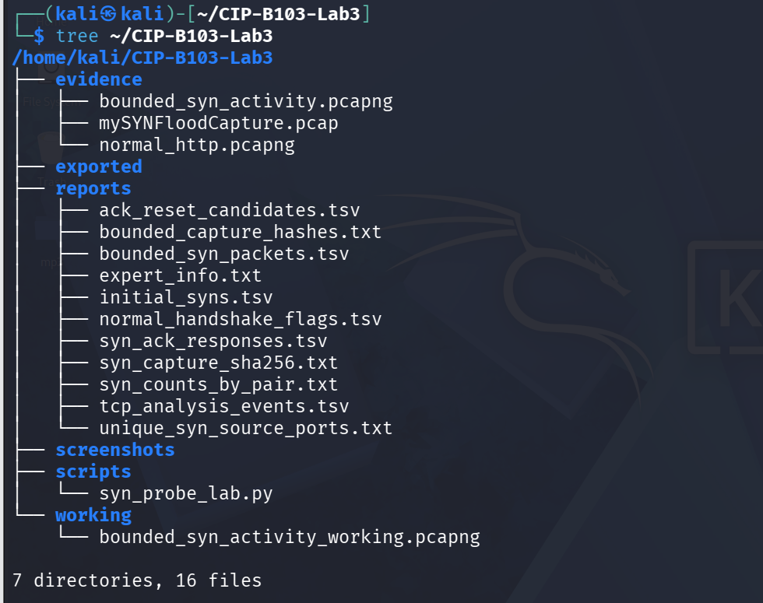
Screenshot 15: Final evidence, reports, scripts and working folder structure (tree).

13. Detection and Mitigation Recommendations
- Alert on elevated SYN-to-completed-handshake ratios per source and destination.
- Monitor SYN backlog exhaustion, retransmissions, connection-state tables and service latency.
- Use SYN cookies, sensible backlog/time-out tuning, upstream rate limiting and DDoS protection where appropriate.
- Retain full packet capture or flow telemetry during incidents and synchronize system clocks.
- Correlate packet evidence with web server, firewall, load balancer and operating-system logs.

Required Screenshots Checklist
☐ Apache service and TCP port 80.
☐ Normal handshake in the baseline capture.
☐ Bounded Scapy script showing target and count.
☐ Initial SYN packet list.
☐ SYN-ACK response list.
☐ Any ACK or RST behaviour.
☐ Counts by source/destination.
☐ Unique source ports.
☐ Normal-versus-suspicious comparison table.
☐ Evidence hashes.

Student Report Template
- Executive summary.
- Authority, scope and safety controls.
- Evidence description and hashes.
- Normal handshake baseline.
- Suspicious-traffic indicators and timeline.
- Quantitative analysis.
- Assessment of whether the capture proves a flood, scan or bounded simulation.
- Detection and mitigation recommendations.
- Appendix of commands and screenshots.

Submission Requirements
- One PDF report named CIP-B103-Lab3_RegNo_FullName.pdf.
- The original or generated PCAP/PCAPNG evidence file and its SHA-256 hash text file.
- A reports folder containing exported CSV/TXT command output and any recovered objects.
- Screenshots must be readable, numbered and referenced in the report narrative.
- Compress the report and evidence outputs into one ZIP named with your registration number and lab number.
- Do not submit passwords or decoded credentials in public discussion channels; include them only in the protected assessment submission where required.

Marking Rubric (100 Marks)
Assessment Area | Marks | What the Instructor Will Check
Safety and evidence handling | 15 | Bounded loopback/host-only scope, hashes and clean stop.
Baseline analysis | 15 | Correct normal handshake identification.
tshark filtering | 20 | Accurate extraction of SYN, SYN-ACK, ACK/RST and fields.
Quantitative findings | 20 | Counts, ports, timing and correlation are correct.
Forensic interpretation | 20 | Clearly distinguishes packet pattern from proof of full DoS impact.
Report quality | 10 | Professional narrative and screenshots.

Instructor Quick Answer Guide
Checkpoint | Expected Observation
Initial SYN filter | tcp.flags.syn==1 && tcp.flags.ack==0.
SYN-ACK filter | tcp.flags.syn==1 && tcp.flags.ack==1.
Normal handshake | Final ACK follows SYN-ACK and application data may follow.
Suspicious pattern | Many initial SYNs with few completed handshakes.
Training limitation | Four packets demonstrate indicators but do not prove service denial.
Strong conclusion | Requires rate, duration, system impact and corroborating logs.

Command Reference Summary
Command | Purpose
tshark -r file -Y FILTER | Analyze a saved capture.
tcp.flags.syn | Filter on the SYN flag.
tcp.flags.ack | Filter on the ACK flag.
tcp.stream | Conversation identifier.
tshark -q -z expert | Show expert analysis.
sort | uniq -c | Count repeated field combinations.

Academic Integrity and Authorization Statement
Student Declaration
I confirm that I completed this lab in an authorized environment, preserved the supplied evidence, did not target any third-party system, and accurately documented my own commands, observations and conclusions.

